Citizen AI: Intelligent Citizen
Engagement Platform

Generative AI with IBM

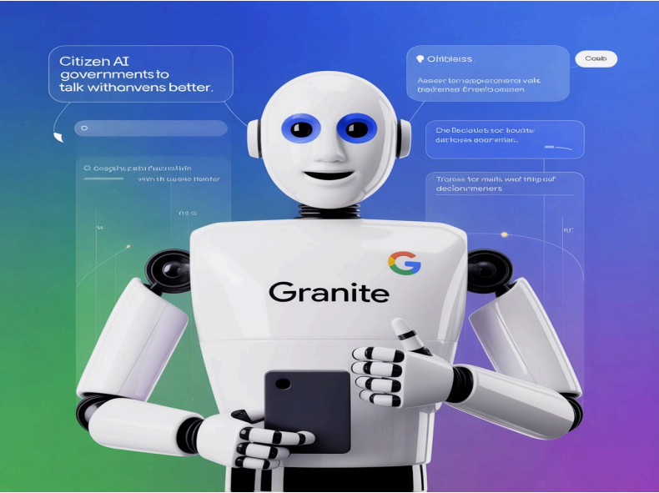

Citizen AI

1. Introduction
• Project Title: Citizen AI
- Team Leader : SOWMIYA K
- Team member : POOJA A,
- Team member : ,SASMITHA S
- Team member : NIVETHITHA M

2. Project Overview
Purpose:
Provide health and wellness insights to citizens using AI.
Enable government/officials to answer health queries and provide wellness recommendations.
Deliver reports on city health status with common issues, facilities, and recommendations
Features:
- Conversational Interface
- Natural language Q&A between citizens and the AI.
- Health Analysis Reports
- Generates city-specific health & wellness reports.
- Responds to personal health-related questions with tips and guidance.
- Generative AI Support
- Uses IBM Granite LLM (instruction-tuned) for response generation.
- User-Friendly Gradio UI
- Tabs for Health Analysis and Citizen Queries with textboxes and outputs.

3. Architecture
- Frontend (Gradio)
- Provides a simple tabbed interface.
- Allows user input (city names, questions) and displays generated outputs.
- Backend (Python with Hugging Face Transformers)
- Loads IBM Granite LLM for health response generation.
- Handles tokenization, model inference, and text decoding.
- LLM Integration
- Uses Hugging Face AutoTokenizer and AutoModelForCausalLM.
- Optimized for GPU (float16, device_map=auto) when available.

4. Setup Instructions

Prerequisites:
- Python 3.9 or later
- transformers, torch, gradio installed
- Internet access to load model
Installation Process:
- Clone project repo
- Install dependencies (pip install transformers torch gradio)
- Run the script in Python/Colab
- Launch Gradio app (app.launch())

5. Folder Structure
- app.py – Main Gradio interface
- model_loader.py – Handles model/tokenizer loading
- functions.py – Health analysis + citizen query functions
- utils.py – Response generation utility

6. Running the Application
Launch the Python script.
Open the Gradio link (http://localhost:7860 or shared link).

Navigate tabs:
Health Analysis → Enter city name → Get report.
Citizen Health Queries → Enter query → Get AI advice.

7. API Documentation (future expansion)
POST /health-analysis – Generates city health report
POST /citizen-query – Responds to health-related questions

8. Authentication (future enhancement)
Currently open for demo.
Plan: Add authentication for secure use (API keys, JWT).

9. User Interface
- Health Analysis Tab – City input + report output.
- Citizen Queries Tab – Textbox for questions + detailed responses.
- Minimalist and easy-to-use interface.

10. Testing
- Unit Testing – Functions (generate_response, health_analysis)
- Manual Testing – Entered cities & queries.
- Edge Cases – Empty inputs, very long prompts, unsupported city names.

11.Screenshort

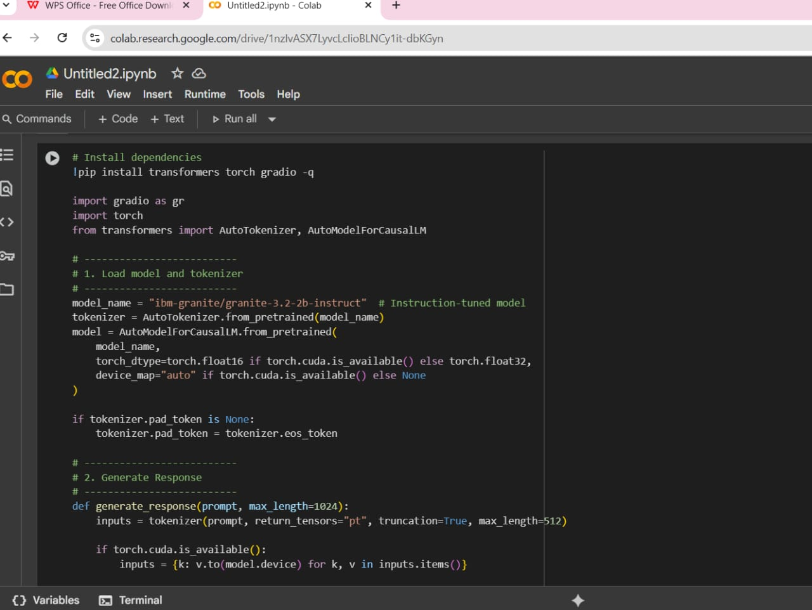
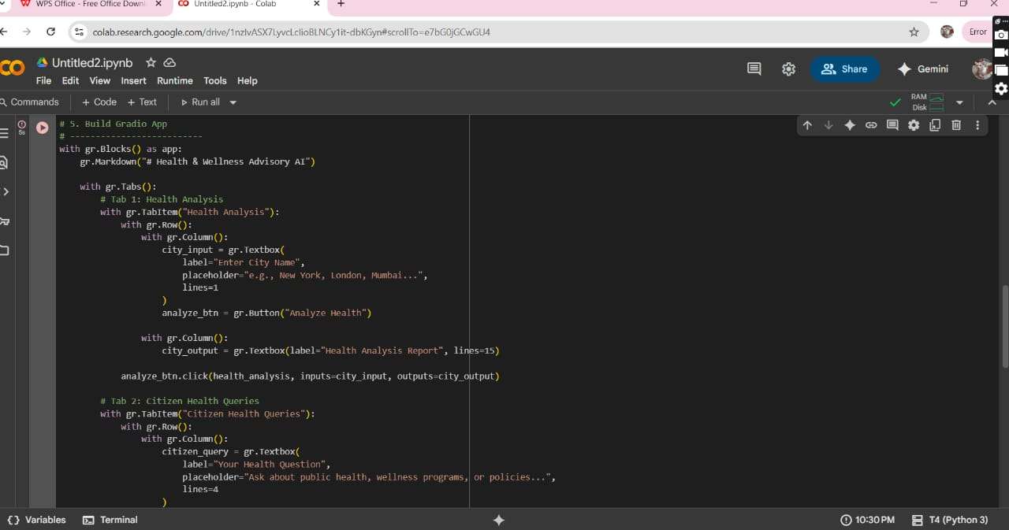

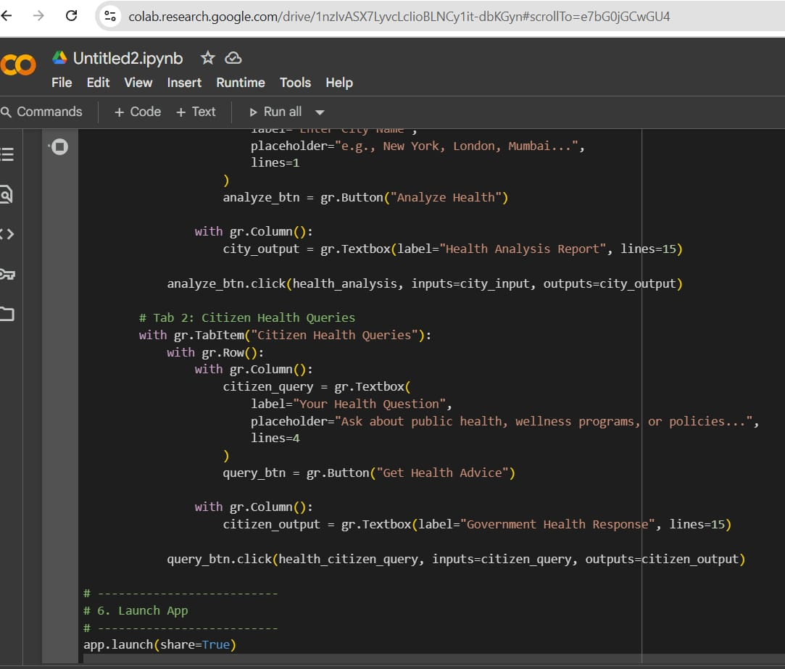
OUTPUT:
